Assignment 3

Version 1: retrieving all the menuItems from the server with Ajax
In this version we simply automatically launch the controller and retrieve all the menu items from the server with an ajax call, but will not show data, will not filter data according to what the user writes, will not take the value from the user input,... this light version will only test the $http service and the ajax call
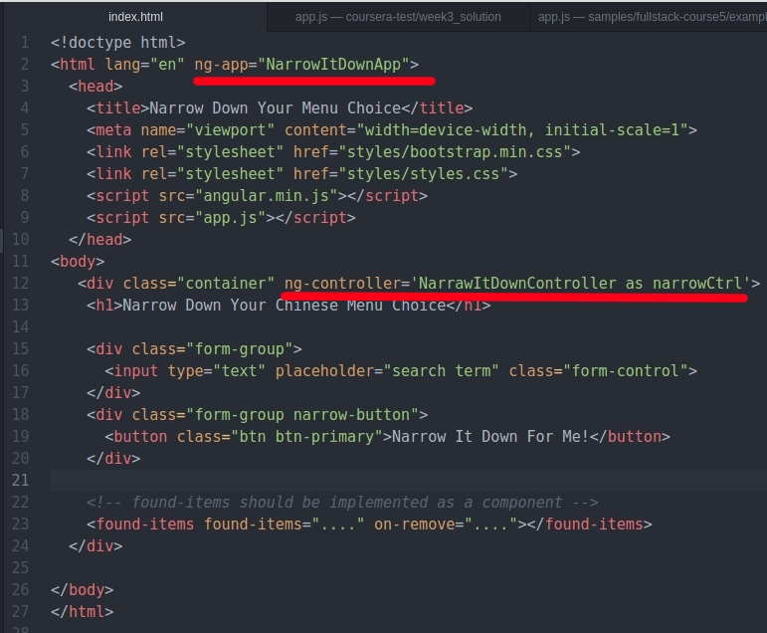 | index.html  Register the ng-app  Register the controller
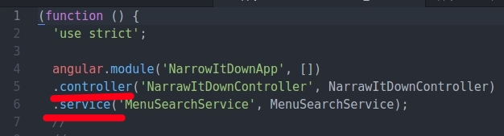 | app.js  Register the controller  Register the service. The service will be the responsible of doing the ajax call
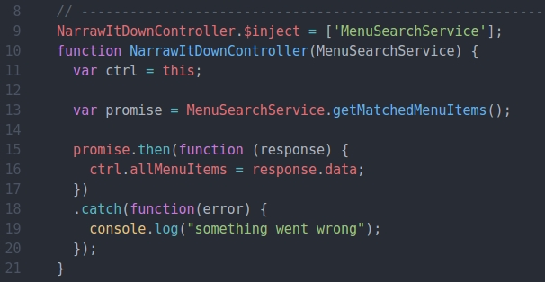 | app.js: Define the controller  Create a promise, which will manage the asynchronous call  Define the .then block, which will be called with the returning data from the async function  thefine the .catch block
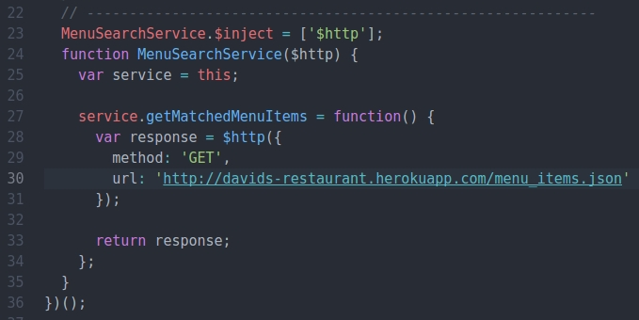 | Define the service  this will be responsible of doing the ajax call, asynchronous function
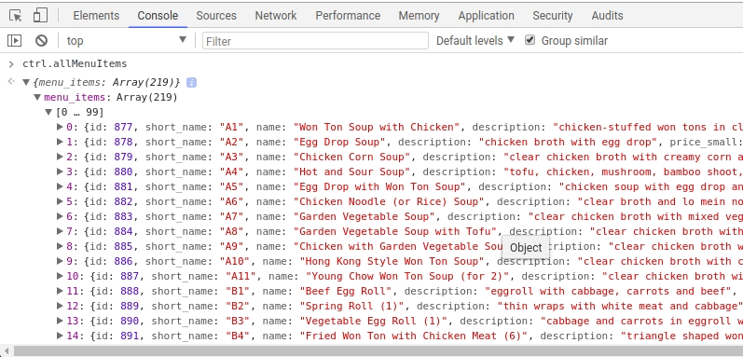 | And everything is working fine!!!  ctrl.allMenuItems contains an array with all the menu items grabbed from the ajax call

Version 2: getting the input text value from the view into the controller and handling the button click event
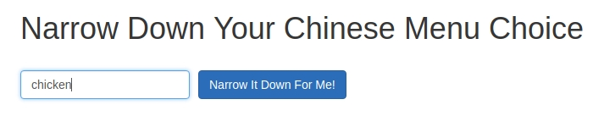 | How to retrieve the input box into the controller?
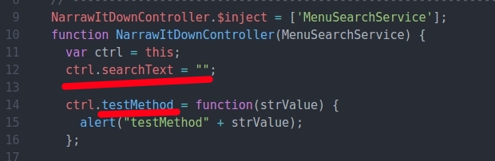 | In the controller, we add a new property called ctrl.searchText  Now, add a ctrl.testMethod which receives a param called strValue  we will open an alert with the strValue received from the view
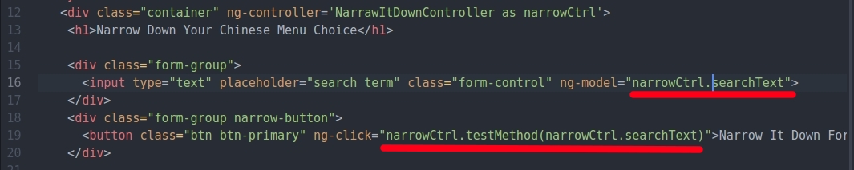 | In the view, simply associate the ctrl.searchText with ng-model to the input text  in the button, add an ng-click attribute pointing to our method
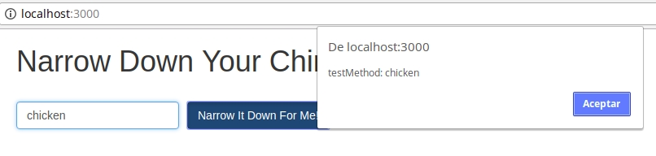 | Everything is working fine!!!

Version 3. Filtering the allMenuItems with the searchText attribute
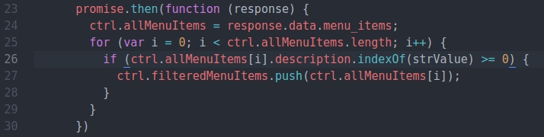 | Modify the .then block so we loop through the ctrl.allMenuItems and push into the ctrl.filteredMenuItems all that matches the strValue, the search text  if (ctrl.allMenuItems[i].description.indexOf(strValue) >= 0)  ctrl.filteredMenuItems.push(ctrl.allMenuItems[i])
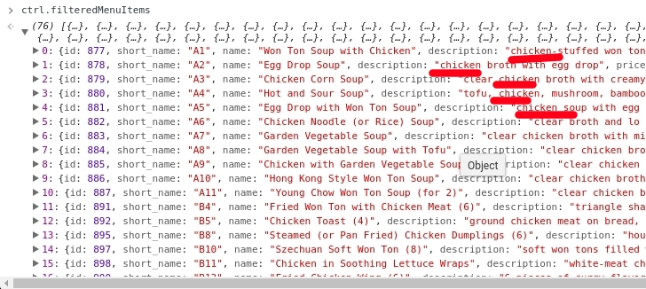 | And it perfectly works

Version 4. Printing the filtered items directly in the view still with no directive
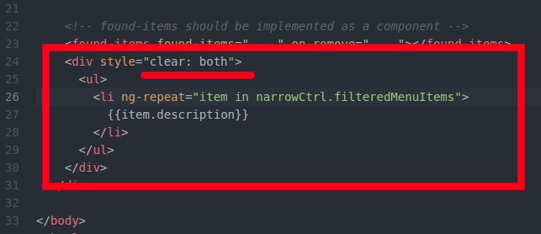  At the end of the view, we add a new div, and with a ng-repeat structure we can loop through the narrowCtrl.filteredMenuItems  Observer how I have used a clear: both style to put this div behind the text box and the button  We are still programming the component directly in the view, not in the directive | 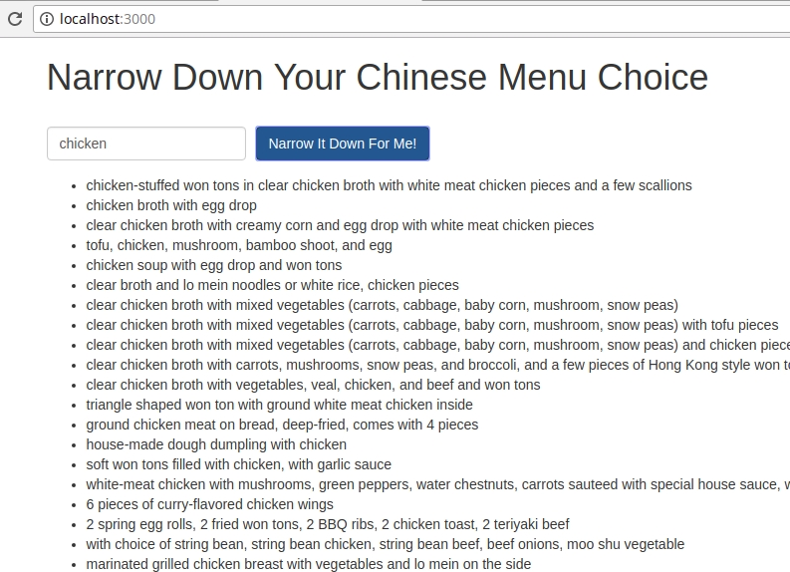  It is perfectly working

Version 5. Adding a remove button to narrow down items. Still with no directive
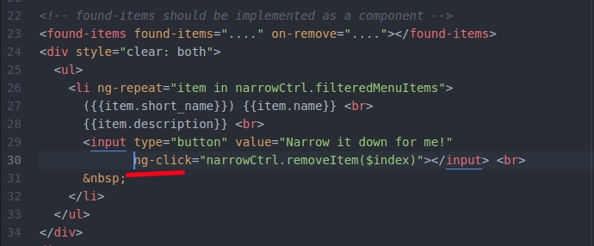  I have added some other properties of each item, such as the name and the short_name and also a button for each item. With ng-click, I associate the button to the removeItem method of the narrow controller | 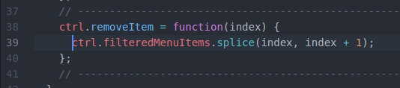  Here it is the code for the removeItem method.  It simply calls the splice array method to remove the item
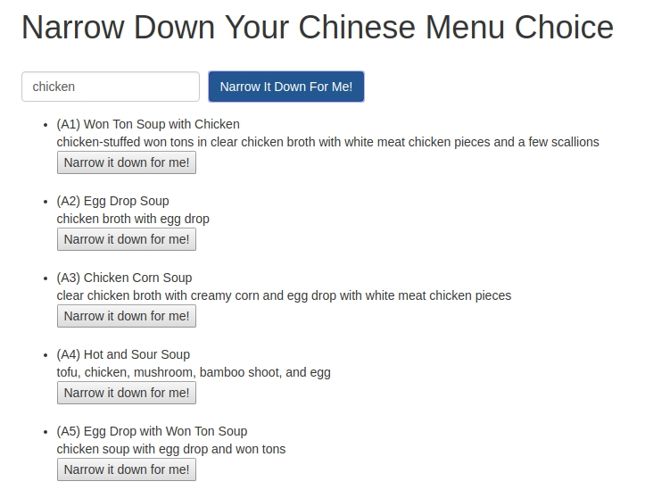
It perfectly works!!!

Version 6: Printing the number of items found and also an error message if no item found
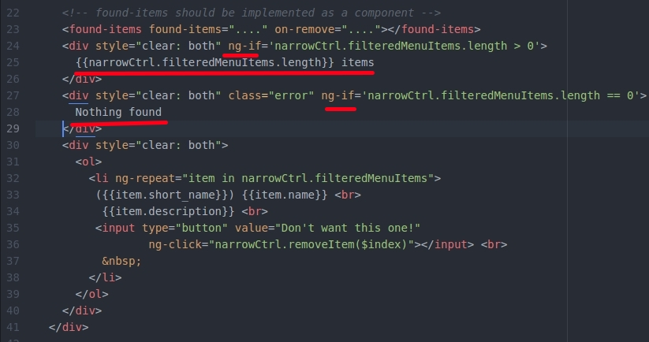  In the view we do add a ng-if block to print the filteredMenuItems length only if any found  Another ng-if structure shows a Nothing found message if the length is 0 | 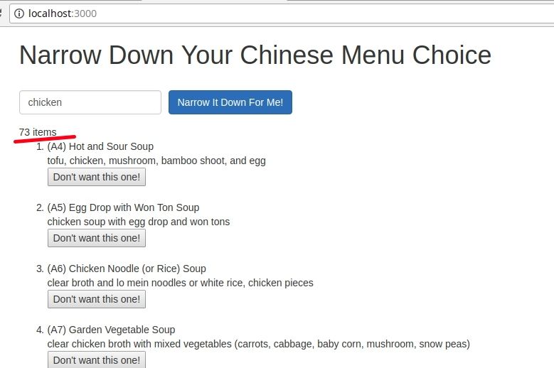  Every thing works fine!

Version 7. Defining the Ajax URL remote resource as a constant
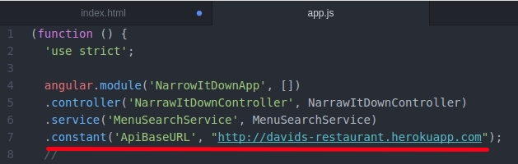  Register the ApiBaseURL .constant in the module | 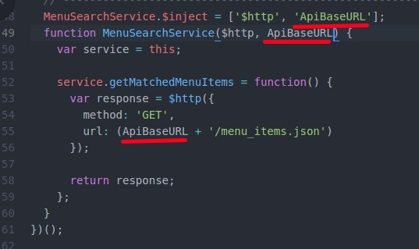  replace the full URL with the ApiBaseURL + the resource .json

Version 8. Basic directive: <found-item> which only contains the name, the description and the short_name of an item
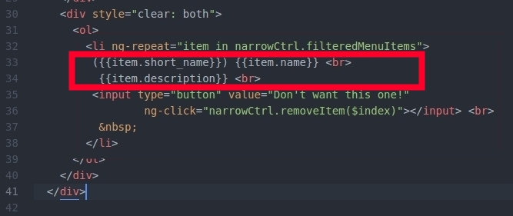 | I will try to convert the values of the item into a directive. Only the section marked will include this html part  Come on!!!
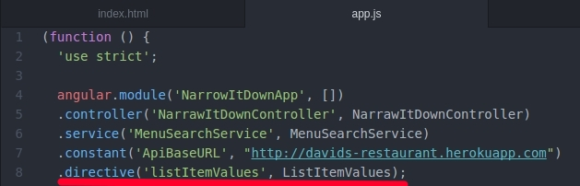  1. Register the new directive foundItemValues using the .directive method  Very important of the camel notation!!! | 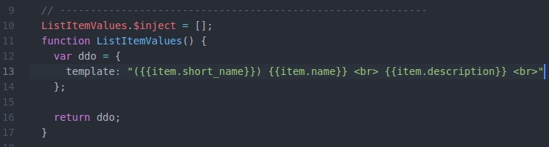  2. Define the template  IMPORNTANT: Althought in the picture it is listItemValues the correct would be foundItem
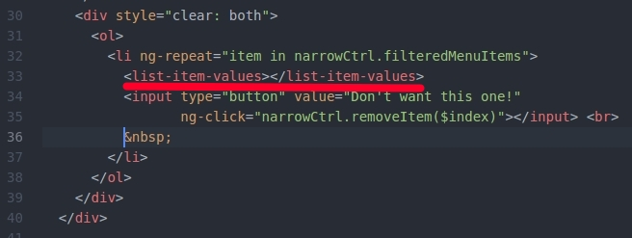  3. Use it in the html code  Remember to use the de-normalized notation <found-item></found-item> | And everything works fine!!!  IMPORNTANT: Althought in the picture it is listItemValues the correct would be foundItem

Version 9. Create the <found-items> element which contains the ng-repeat, wraps one item values <found-item-values> and the button to remove the item
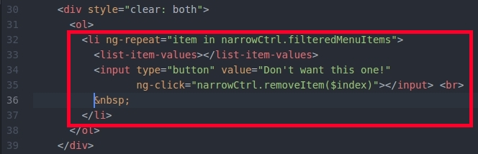  1. Our <found-items> will contain all this html code | 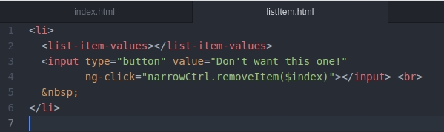  2. Create a new file called foundItems.html with exactly the code of the previous block  Be careful, remove the ng-repeat structure so it will be outside
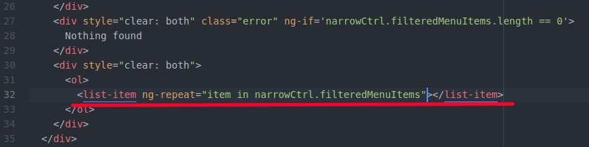  3. Replace the full html block for the <found-items> html elem we are creating just now  IMPORNTANT: Althought in the picture it is list-item the correct would be found-items | 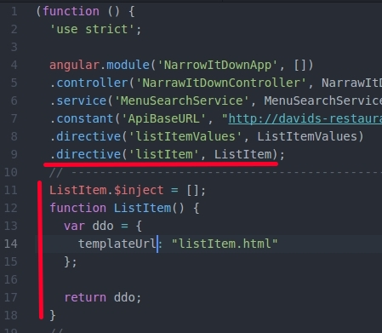  4. Register the new .directive foundItems. Remember the camel notation  5. Define the dirctive by using templateUrl pointing to our foundItems.html file

Version 10. Max html code reuse. The <found-items> component contains the number of items counter and the error message inside
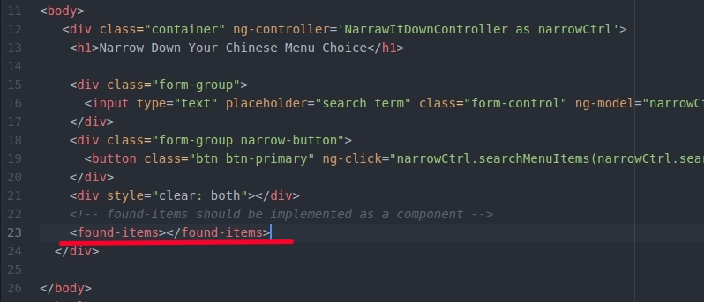  By simply adding this line <found-items></found-items> we create a found items compont, which also include the items counter and the "Nothing found" message | 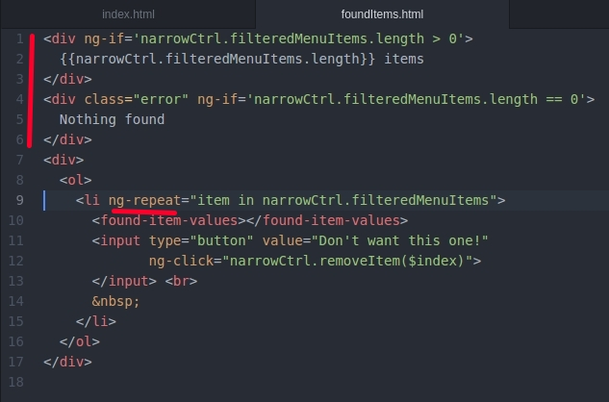  To to this, the found-items component must include the <div> used for items counter and the <div> for the error message

Version 11. Isolating the directive scope. Changing the name of the controller in the view will not affect the directive, the component
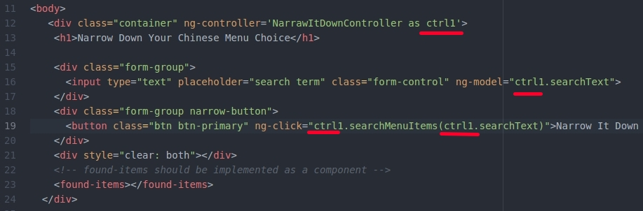  1. I have changed the controller as syntax using ctrl1 instead of narrowCtrl alias and now, nothing works.  This is because the directive is using its parent scope. Lets isolete it | 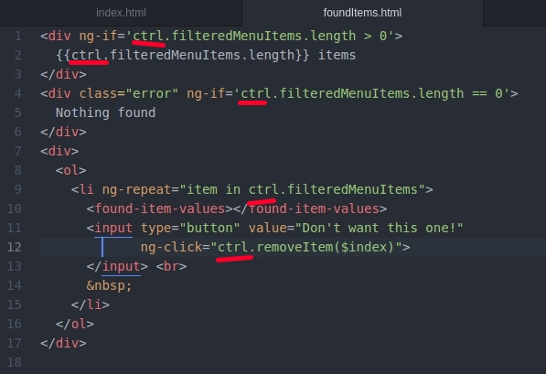  2. In the template, we will change narrowCtrl by a generic name ctrl. I have removed any reference to narrowCtrl to use a generic name which is ctrl
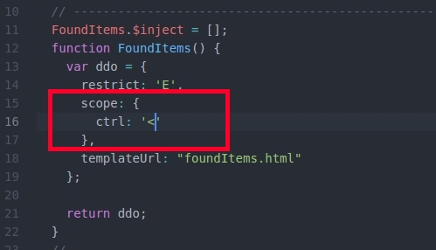  3. In the directive, lets define its own scope. we use the '<' attribute to define it is not modified in the view, so it is a one-way binding property | 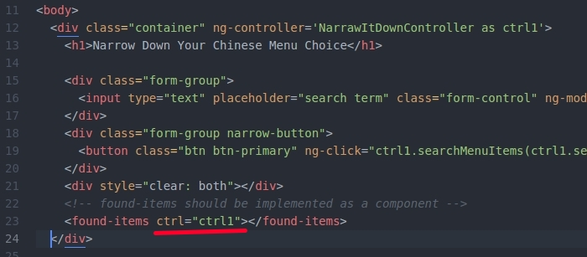  4. In the view, we have to pass the own property for the component in which we do ctrl="ctrl1"  And everything works fine again!!!

Version 12. Removing items inside the controller NOT inside the template
Very important
I have renamed several elements so it would be easier for me to understand
foundItem: the directive used to simply display the name, the description and the short_name of the found items it is translated into <found-item>
foundList: the directive used as a full component to manage the found list. It is translated into <found-list>
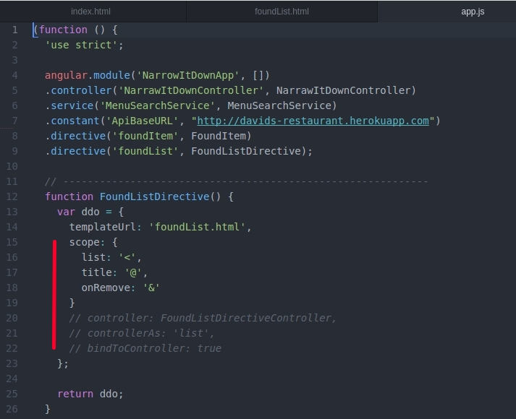 | FoundListDirective.  This directive is used to create the <found-list> custom html element  foundItems: '<'  title: '@'  the title, which will be used to display the number of elements of the list  onRemove: '&'  This will store a reference to the method that will manage the remove click button event. This must be visible outside to provide the method  I have commented all the code related with the inner controller because, for this example, it is not necessary
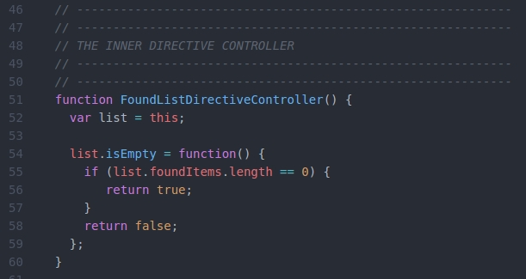 | Code associated with the inner controller FoundListDirectiveController.  Not necessary
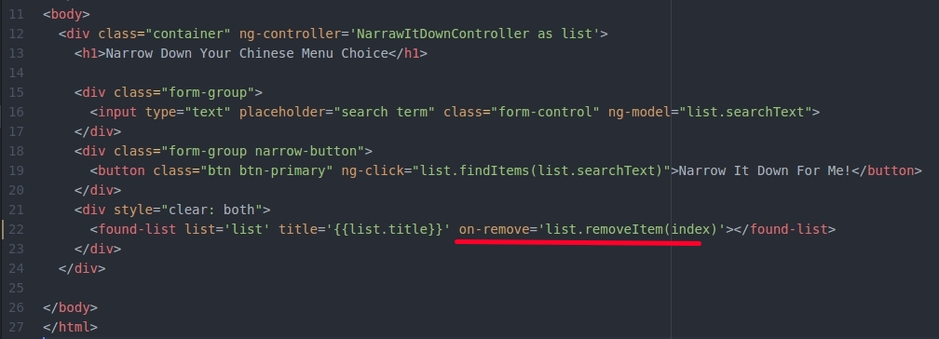 | The view index.html code  using <found-list> element and the on-remove attribute  We do not specify nothing for the index paramenter in the list.removeItem(index) call  It is only a map object
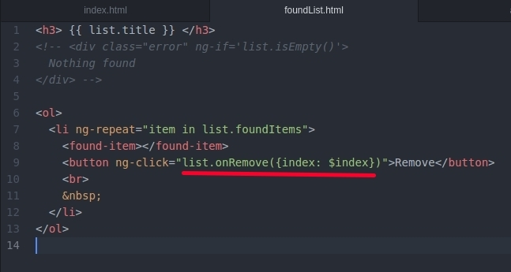 | foundList.html  The template modified with the onRemove call and the map object {index: $index}
And everything works perfectly

